Project

INFO 8490

Network Security I

GROUP-6

Prit Patel Nikhil Rajani

**8568891 8150948**

Harmandeep Singh Haril Majmundar

**8629001 8150906**

Amrinder Singh

**6820294**

Table of Contents

Project 3

Description 3

Preparation 3

Configuration 4

Observations/Deliverables 21

Reflection 29

# Project

## Description

In this project, we will be using EIGRP, VLAN and OSPF we have built a topology as per the project documentation. After establishing a connection, we will check the connection between the department, here we have three department names as HR, Production and Marketing we also have server in the infrastructure, which are able to communicate. Here we have used TFTP server while building our project, initially we have used packet tracer and then we implemented it on real devices. Here below we have attached the configuration files of all the routers and switches which we have used in the infrastructure.



## Preparation

To establish a network, we need some basic requirements such as:

* Software like Putty and TFTP server.
* Cables like cross-over and ethernet.
* Access to the real devices like router, switches and multilayer switch.
* Here the topology is done using the project schematic.

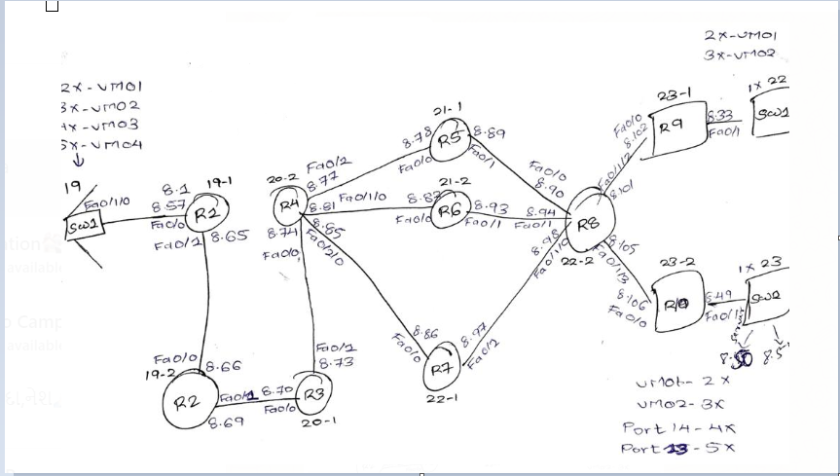

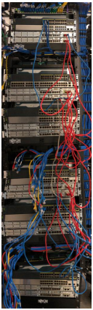

## Configuration

Here, we have stated the configuration which we have done on the routers, after doing all the configuration we will check the communications between the departments.

WR1:

Router1 relates to the switch 1 and router 2. network 172.16.8.64/30 is configured between router 1 and router 2. On router 1 EIGRP protocol is used for configuration.

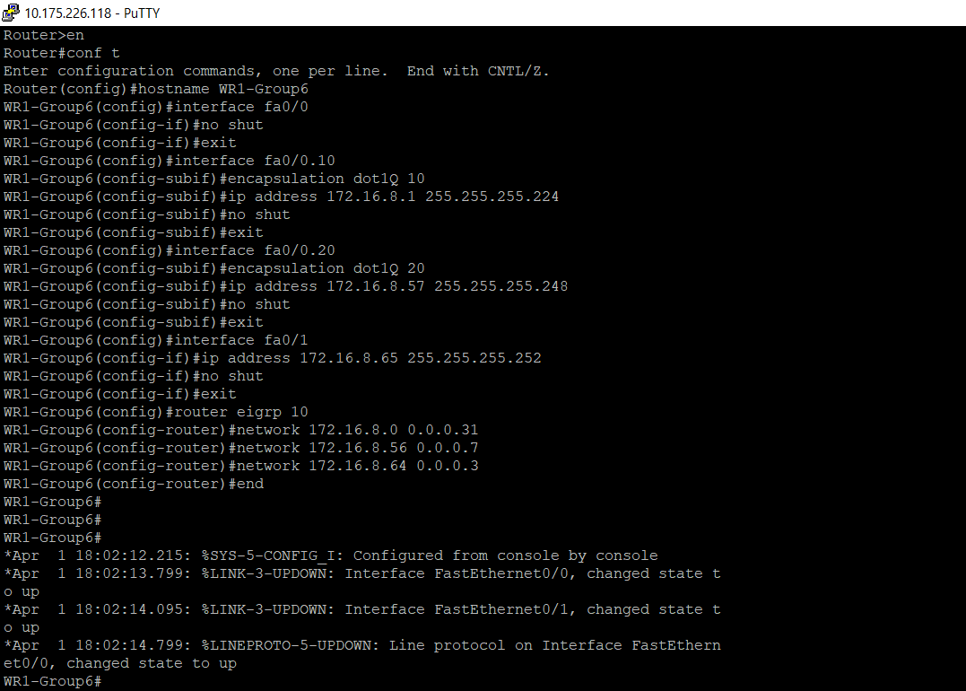

Figure 1.1: Configuration on router 1

WR2:

Router2 relates to the switch 1 and router 3. network 172.16.8.68/30 is configured between router 2 and router 3. On router 2 EIGRP protocol is used for configuration

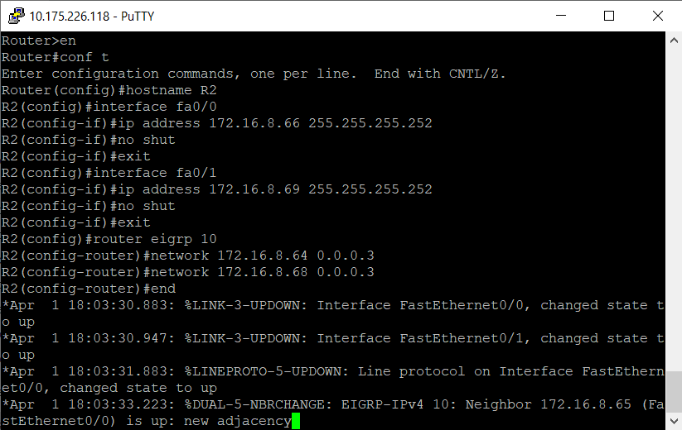

Figure 1.2: Configuration on router 2

WR3:

Router3 relates to router 2 and router 4. Network 172.16.8.72/30 is configure between router 3 and router 4. On router EIGRP protocol is configured.

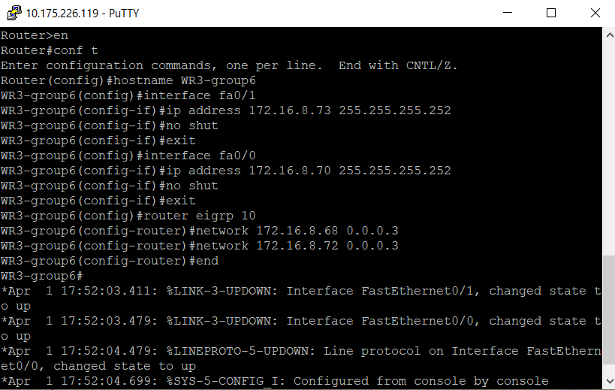

Figure 1.3: Configuration on router 3

WR4:

Router4 relates to R5, R6 and R7. Network 172.16.8.76/30 is configured between R4 and R5. Network 172.16.8.80/30 is configured between R4 and R6. Network 172.16.8.84/30 is configured between R4 and R7. On router 4 EIGRP and OSPF routing protocols are enabled. Redistribution command is given on Router 4 so that both the routing protocols can communicate with each other.

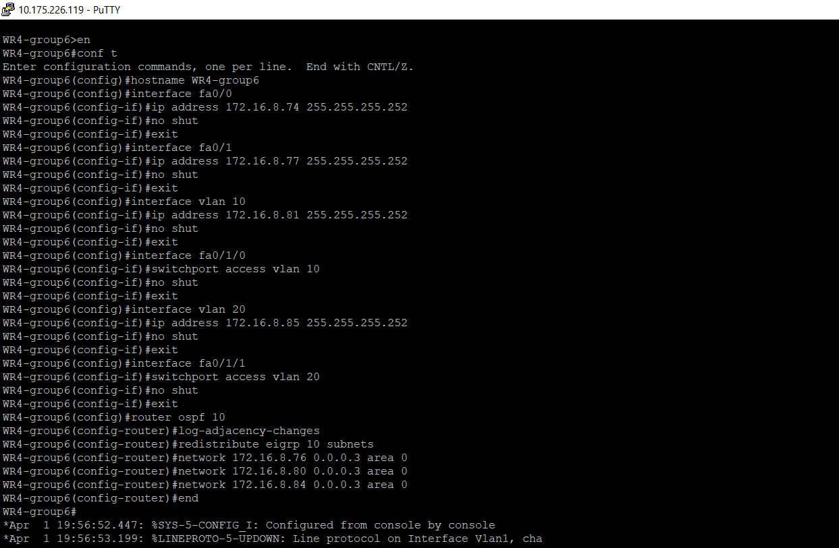

Figure 1.4: Configuration on router 4

WR5:

Router 5 relates to the router 4 and on the other side it relates to the router 8. the network 172.16.8.76/30 between router 4 and router 5 and network 172.16.8.88/30 is configured between router 5 and router 8 and OSPF routing protocol is configured.

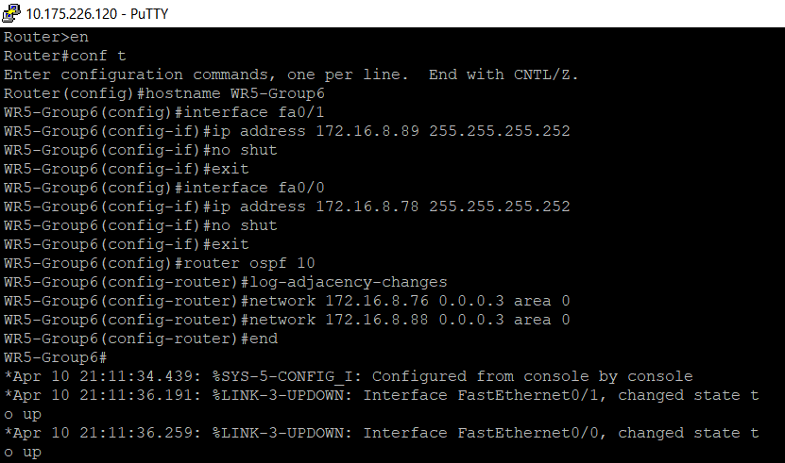

Figure 1.5: Configuration on router 5

WR6:

Router 6 relates to the router 4 and on the other side it relates to the router 8. the network 172.16.8.80/30 between router 4 and router 6 and network 172.16.8.92/30 is configured between router 6 and router 8 and OSPF routing protocol is configured.

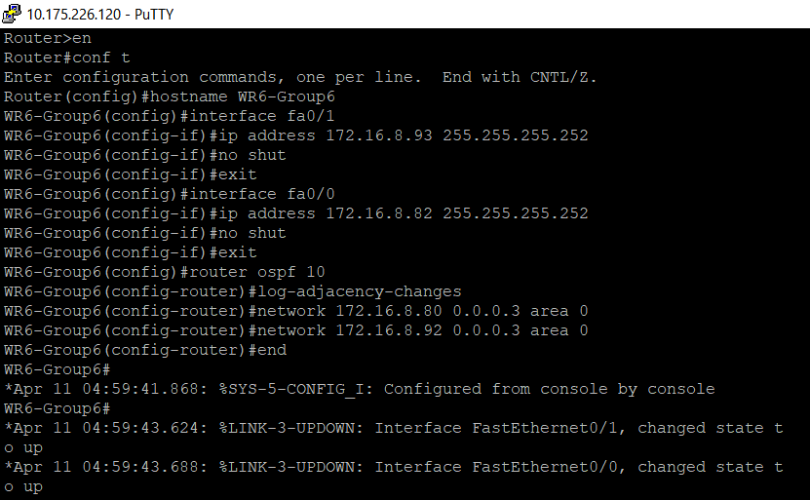

Figure 1.6: Configuration on router 6

WR7:

Router 7 relates to the router 4 and on the other side it relates to the router 8. the network 172.16.8.84/30 between router 4 and router 7 and network 172.16.8.96/30 is configured between router 7 and router 8 and OSPF routing protocol is configured.

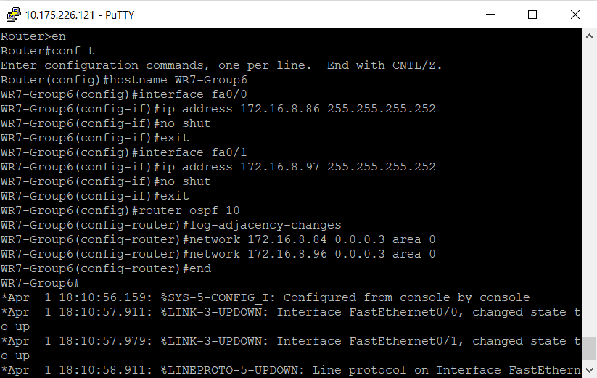

Figure 1.7: Configuration on router 7

WR8:

Router 8 relates to R5, R6 and R7. Network 172.16.8.88/30 is configured between R5 and R8. Network 172.16.8.92/30 is configured between R6 and R8. Network 172.16.8.96/30 is configured R7 and R8. Network 172.16.8.100/30 is configured between R8 and R9. Network 172.16.8.104/30 is configured between R8 and R10. On router 8 static and OSPF routing protocols are enabled. Redistribution command is given on OSPF so that both the routing protocols can communicate with each other. for the server communication protocols, we have added default route in static routing.

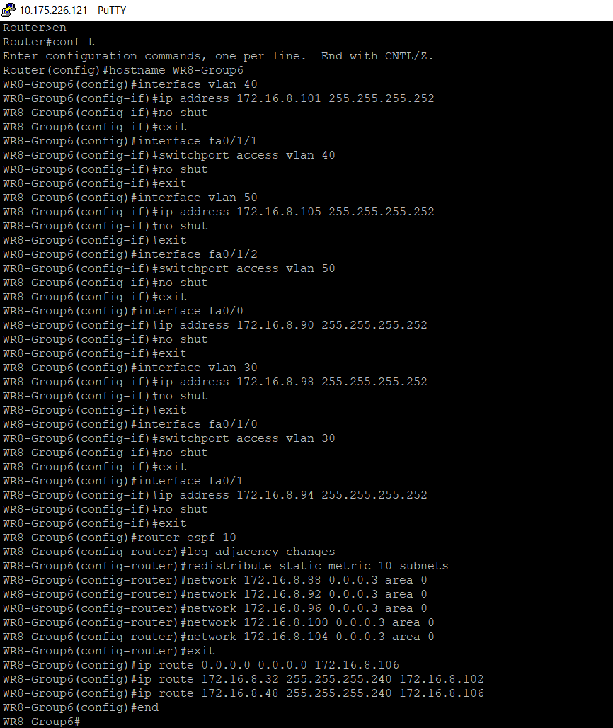

Figure 1.8: Configuration on router 8

WR9:

Router 9 relates to router 8 and switch 2. network 172.16.8.32/28 is configured between the router 9 and switch. Static routing is set on router 9, switch 2 is connected to marketing section. In this router we have configured default route in static route for server communication.

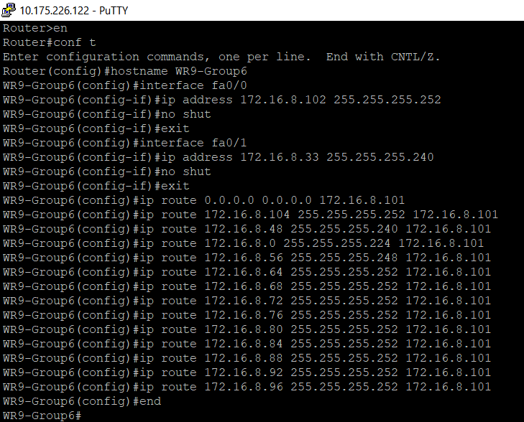

Figure 1.9: Configuration on router 9

WR10:

Router10 relates to router 9 and switch 3. network 172.16.8.48/30 is configured between router 10 and switch 3. static routing is set on router 10. switch3 relates to the servers.

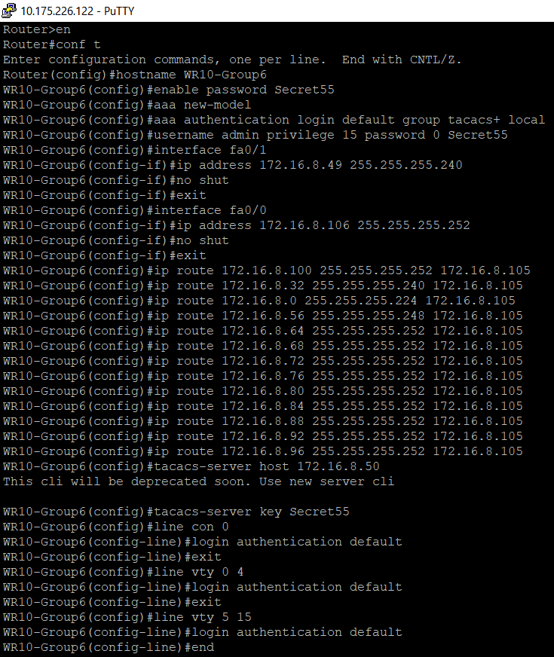

Figure 1.10: Configuration on router 10

We have seen all the configuration now we will see the successful communication between the departments and server

The Ip address are as follows for the departments PC

Production :172.16.8.2/27

HR:172.16.8.58/29

Marketing :172.16.8.34/28

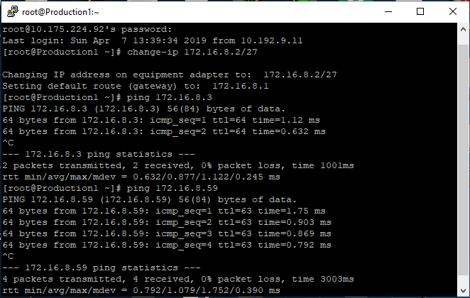

Figure 1.11: Communication from Production to HR and Marketing

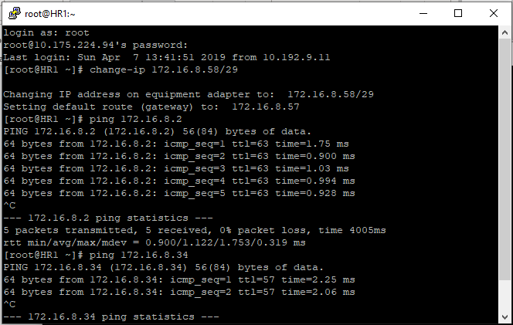

Figure 1.12: Communication from HR to Production and Marketing

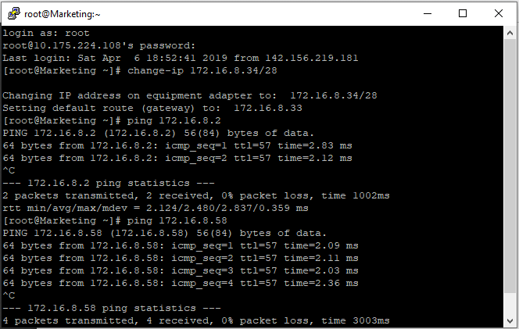

Figure 1.12: Communication from Marketing to HR and production

Here we have installed telnet by the command **yum install telnet** and tried the communication to the router 10 as on router 10 we have configured AAA authentication server

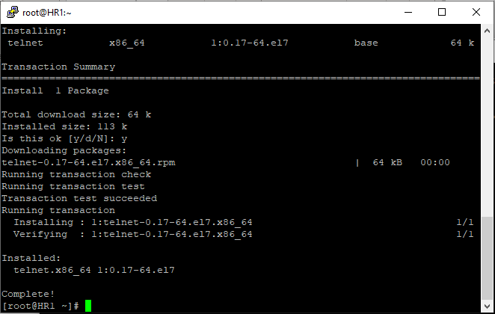

Figure 1.13: Installed telnet on VM by using command yum install telnet

For the telnet we must write the telnet and the router ip address, here as we are using the router 10 as server, it will be telnet 172.16.8.106

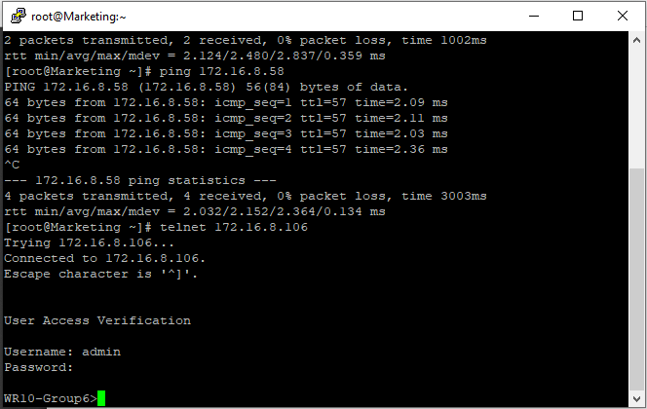

Figure 1.14: Telnet from marketing to router 10

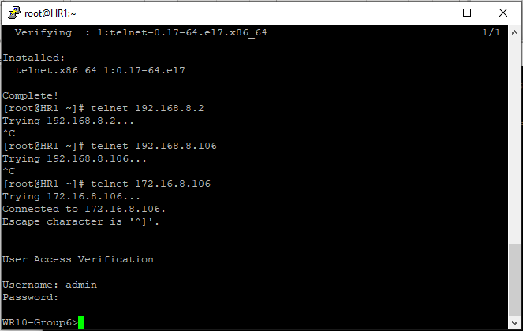

Figure 1.15: Telnet from HR to router 10

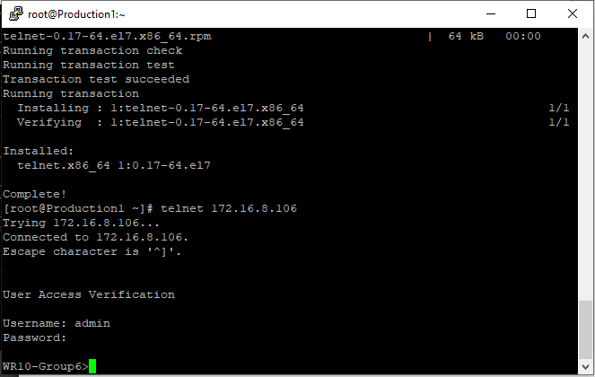

Figure 1.16: Telnet from production to router 10

Communication from server to other departments

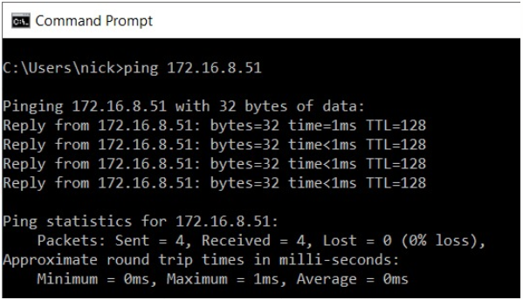

Figure 1.17: Server 1 to Server 2 ping

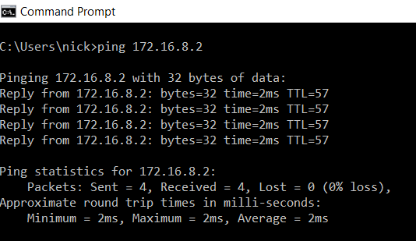

Figure 1.18: Server 1 to Production

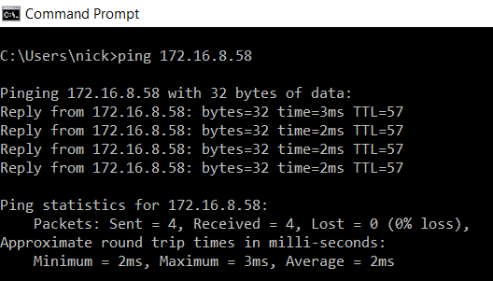

Figure 1.19: Server 1 to HR ping

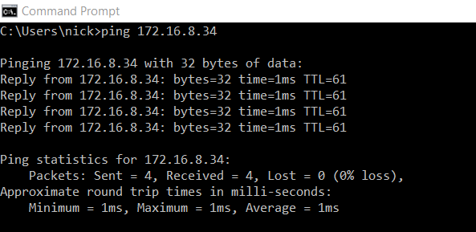

Figure 1.20: Server 1 to Marketing

## Observations/Deliverables

1. Mention brief Description about your company:

Network for an **Alacrity e-commerce solutions Pvt. Ltd.** company has been configured, with number of sites on different locations, with different routing protocols used on certain locations.

Alacrity E-commerce has many fortune international clients, which formulate the designed ecommerce solutions. They provide high quality of service to their offshore clients across the globe, they provide professional and exclusive ecommerce solutions. for this we have involved in designing and developing the network as they are planning to grow more in that field, for this we will develop and network infrastructure that will help them to start the new business on their new location.

1. Lab schematic /topology

Number and types of devices used in lab are mentioned below. Routers= 10, Access-Layer Switch=3, Servers and PCs are also used as per requirements. Pasted below is the network diagram.

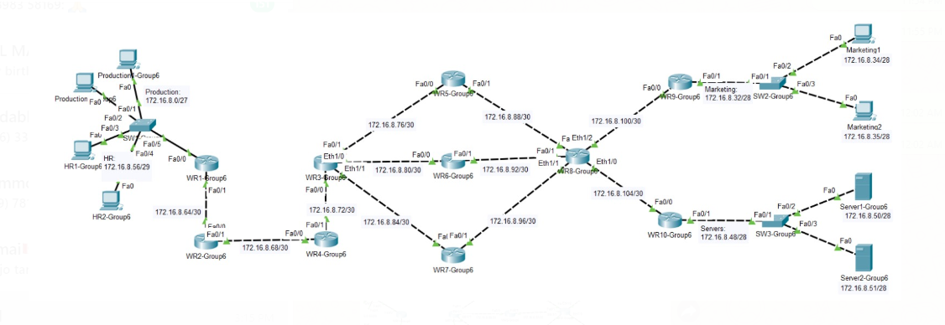

1. IP Address Plan

|  |  |  |  |  |
| --- | --- | --- | --- | --- |
| **Device** | **Interface** | **IP Address** | **Subnet Mask** | **Gateway** |
| R1 | Fa0/0.10 | 172.16.8.1 | 255.255.255.224 | NA |
| Fa0/0.20 | 172.16.8.57 | 255.255.255.248 | NA |
| Fa0/1 | 172.16.8.65 | 255.255.255.252 | NA |
| R2 | Fa0/0 | 172.16.8.66 | 255.255.255.252 | NA |
| Fa0/1 | 172.16.8.69 | 255.255.255.252 | NA |
| R3 | Fa0/1 | 172.16.8.73 | 255.255.255.252 | NA |
| Fa0/0 | 172.16.8.70 | 255.255.255.252 | NA |
| R4 | Fa0/0 | 172.16.8.74 | 255.255.255.252 | NA |
| Fa0/1 | 172.16.8.77 | 255.255.255.252 | NA |
| Fa0/1/1 | 172.16.8.85 | 255.255.255.252 | NA |
| Fa0/1/0 | 172.16.8.81 | 255.255.255.252 | NA |
| R5 | Fa0/1 | 172.16.8.89 | 255.255.255.252 | NA |
| Fa0/0 | 172.16.8.78 | 255.255.255.252 | NA |
| R6 | Fa0/1 | 172.16.8.93 | 255.255.255.252 | NA |
| Fa0/0 | 172.16.8.82 | 255.255.255.252 | NA |
| R7 | Fa0/0 | 172.16.8.86 | 255.255.255.252 | NA |
| Fa0/1 | 172.16.8.97 | 255.255.255.252 | NA |
| R8 | Fa0/0 | 172.16.8.90 | 255.255.255.252 | NA |
| Fa0/1/0 | 172.16.8.98 | 255.255.255.252 | NA |
| Fa0/1 | 172.16.8.94 | 255.255.255.252 | NA |
| Fa0/1/1 | 172.16.8.101 | 255.255.255.252 | NA |
| Fa0/1/2 | 172.16.8.105 | 255.255.255.252 | NA |
| R9 | Fa0/0 | 172.16.8.102 | 255.255.255.252 | NA |
| Fa0/1 | 172.16.8.33 | 255.255.255.240 | NA |
| R10 | Fa0/1 | 172.16.8.49 | 255.255.255.240 | NA |
| Fa0/0 | 172.16.8.106 | 255.255.255.252 | NA |
| Production1(VM01) | Fa0/2 | 172.16.8.2 | 255.255.255.224 | 172.16.8.1 |
| Production2(VM02) | Fa0/3 | 172.16.8.3 | 255.255.255.224 | 172.16.8.1 |
| HR1(VM03) | Fa0/4 | 172.16.8.58 | 255.255.255.248 | 172.16.8.57 |
| HR2(VM04) | Fa0/5 | 172.16.8.59 | 255.255.255.248 | 172.16.8.57 |
| Marketing1(VM01) | Fa0/2 | 172.16.8.34 | 255.255.255.240 | 172.16.8.33 |
| Marketing2(VM02) | Fa0/3 | 172.16.8.35 | 255.255.255.240 | 172.16.8.33 |
| Server1 | Fa0/2 | 172.16.8.50 | 255.255.255.240 | 172.16.8.49 |
| Server2 | Fa0/3 | 172.16.8.51 | 255.255.255.240 | 172.16.8.49 |

1. Description of Devices

Ten 2811 Series Routers have been used (namely WR1-WR10-Group6). Two 2960 access-layer switches have been used (namely SW1-Group6). PCs and Servers are also used as per required. Here I have attached the screenshot of description on devices.

Router 1 relates to the router 2 with network of 172.16.8.64/30 and connected with switch 1 with network where there are two subnetworks i.e. for production department it is 172.16.8.0/27 and for HR department it is 172.16.8.56/29.

Router 2 relates to the router 1 and router 3 with network 172.16.8.68/30.

Router 3 relates to the router 4 with network 172.16.8.72/30.

Router 4 relates with 3 router which are router 5,6 and 7 wit network 172.16.8.76/30, 172.16.8.80/30, 172.16.8.84/30 respectively.

Router 5,6 and 7 relates to router 8 with network 172.16.8.88/30, 172.16.8.92/30, 172.16.8.96/30 respectively.

Router 8 relates to the router 9 and router 10 with network 172.16.8.100/30, 172.16.8.104/30 respectively.

Router 9 relates to Switch 2 with network 172.16.8.32/28 and further switch 2 relates to marketing end devices.

Router 10 relates to Switch 3 with network 172.16.8.48/28 and further switch 3 relates to Servers of our organization.

1. Labeling of the devices

Every device has been tagged with proper hostname (WR1-Group6 -WR10-Group6 routers & Sw1-Sw3-Group6) for end devices, we have named it as Production1-2, HR1-2, Marketing1-2.



1. Specify any if Strategy or plans was used by your group for accomplish the project task

Activity has been performed gradually on tasks bases; different tasks have been performed by all the members in coordination as this project is done by the group of five we have distributed our work our group member Harman decided to perform VLSM after creating a raw diagram on paper our group member Nikhil design the network on the software called as packet tracer and then we all configured different routing protocol on different routers. The testing and troubleshooting are all done by Prit and Haril in our group, at last all confirmation and documentation is done by Amrinder. we got a successful result to develop this project.

We also faced some difficulties while working on this project on router 8(WR8-Group6) and router 9 (WR9-Group6) we were not able to communicate server with other VMs, so we figured out that we need to configure default routes on both routers. Also, on router 8 ospf network we need to also specify router 9 and router 10 routes also.

1. Describe the type of Static Route used and why?

Static routes like standard and default both are used in our network, have been defined to get desired connectivity throughout the network. The static route has been configured on router 8,9 and router 10 which is on the right side of the topology. Below figure shows the static route which we have done by using command show ip route.

WR8:

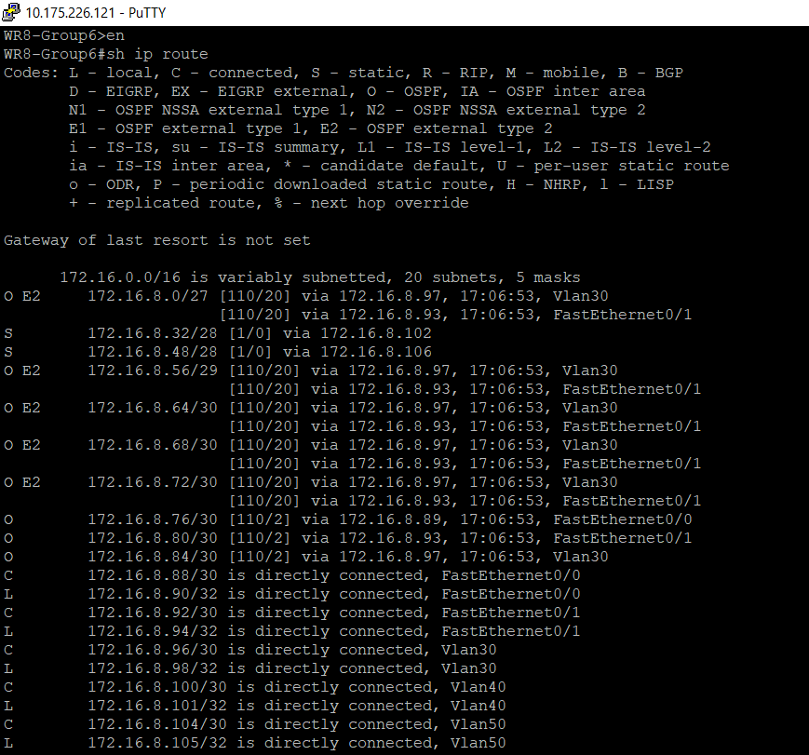

WR9:

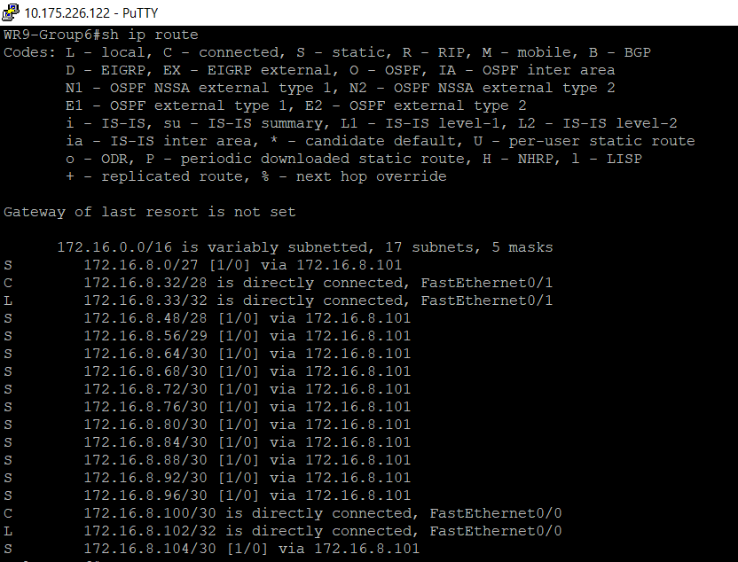

WR10:

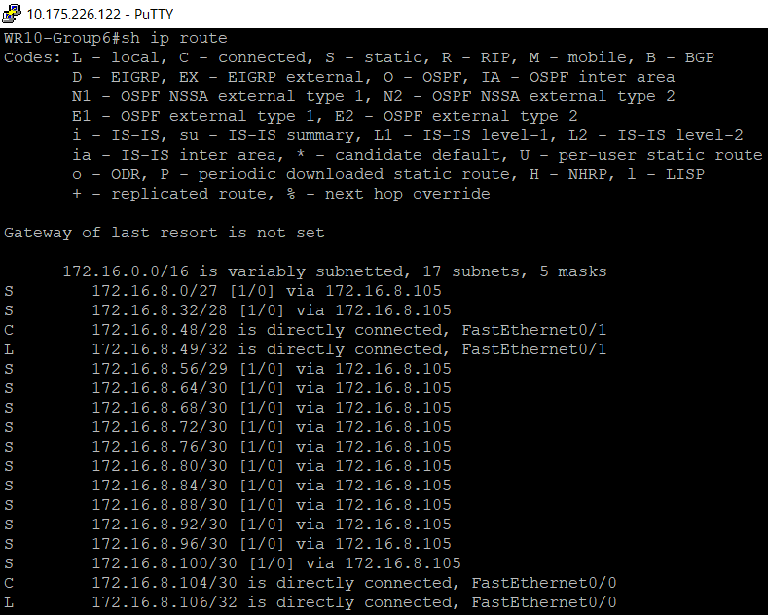

1. Describe and explain the metric used and why for inter-routing protocol communication

Redistribution is performed to translate routes of a routing protocol into other routing protocol; it has been performed on two places on Routers R4 and on R8.

OSPF used cost as it’s metric, which is derived from the bandwidth of a link, while EIGRP uses composite metric (Bandwidth, Load, delay, reliability & MTU). On R4 Mutual redistribution has been performed between EIGRP and OSPF. EIGRP uses 5 K-Values (Bandwidth, Load, delay, reliability & MTU from K1 to K5) as its metric, command is pasted below.

**Redistribute ospf 10 metric 10000 100 255 1 1500**

These values should be selected carefully and as per scenario.

1. Observe the Routing Table on the router R2. look for the EIGRP external routes and their metric. Pick any one external route metric and explain the metric calculations

EIGRP external routes sample from R2.

D EX 172.16.8.32/28 [170/286720] via 172.16.8.70, 17:18:13, fastethernet0/1

Here the network is 172.16.18.12

Metric can be calculated by

Metric= 256*((K1*Bandwidth) + (K2*Bandwidth)/(256-Load) + K3*Delay) *(K5/(Reliability + K4)))

Here K1 and K3 are 1, and K2, K4 and K5 are 0.

So simplified formula is. EIGRP Metric = 256*(Bandwidth + Delay)

Metric =256*(1000+120)

=286720

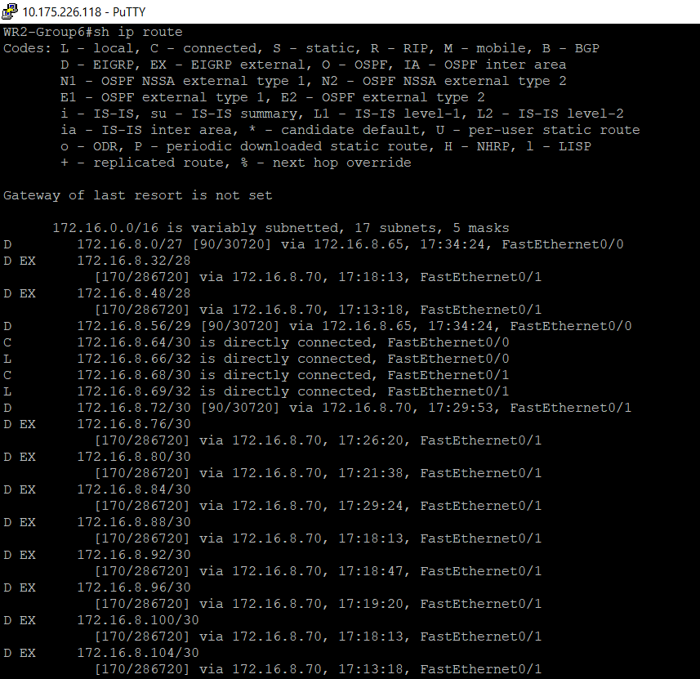

1. Which router is acting as ABR Router and why?

There is no ABR in the topology because we are using single area OSPF but ABR (Area Border Router) persist between multiple areas of OSPF. ABR is the router which establishes a connection to the backbone area and with the other OSPF area. we can also define the area ID with a decimal number i.e.,0.0.0.0 or standard number which is 0. The ASBR is the route which connects with the OSPF area and with the other routing protocols like EIGRP, RIP, static etc. so according to our topology there is no ABR but **ASBR** is present in our topology.

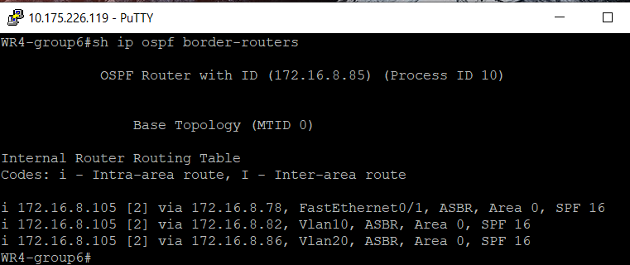

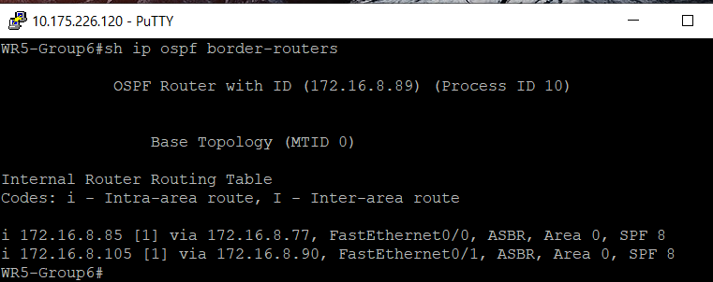

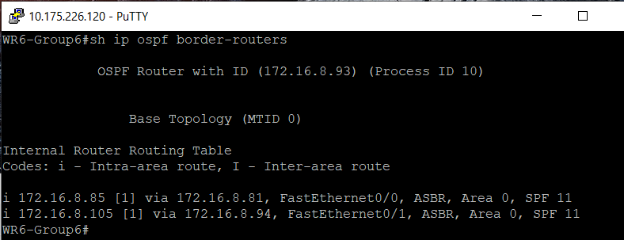

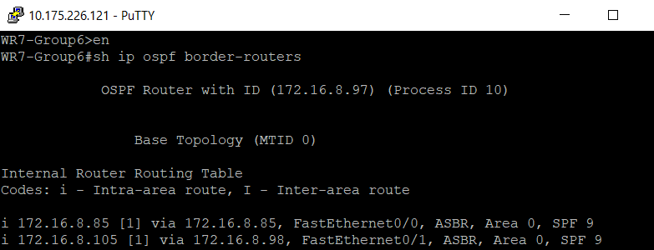

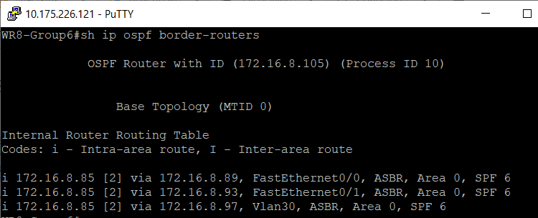

1. Observe the Topology Database created on R8 by the OSPF protocol and explain various type of LSA recorded by the protocol

By the help of show ip ospf database we can check the topology, here in our area we can see the LSA types as type 1-router link state, type 2-Network state link state and type5 which is external link state.

LSA Type 1 is the router which announces its presence and lists the links to other router or the network which is in the same area

LSA Type 2 is the router are flooded by their own area only

LSA Type 5 contains information which is imported into OSPF from other routing processes and the link state ID of the type 5 LSA is the external network number

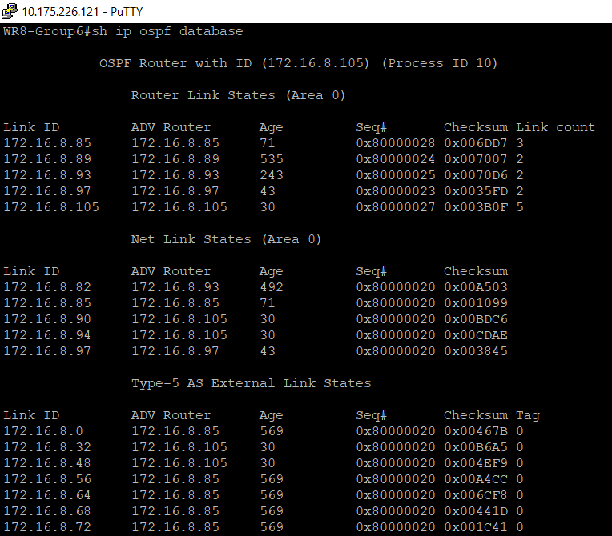

## Reflection

On all the routers IP addresses has been configured by performing VLSM.This is a multi-protocol environment so EIGRP, OSPF and Static routing have been configured. Refer to Packet tracer topology, different network portions have been tagged with protocol name and encircled as well to get better understanding of the network. For Connectivity purpose between the different routing protocols redistribution has been performed. VLAN are created on the switches as per requirements and certain ports have also been assigned to respective VLANs. AAA has been configured on R10 with username as admin & password as Secret55 and authentication on Console and Telnet has been set local through AAA.